ECE 4250 Lab 7

Test Clock with Generics

Sterling LaBarbera

14096504

# Objective

In this lab, we used generics to represent the period for a clock, and we instantiated multiple clocks with different periods from the same generic range. The clocks had periods of 0.5s, 1s, 2s, and 4s giving a binary counter on the LEDs.

# Lab Work

Using the templates and the power point for this lab, we were able to specify GenClock as a clock with period from 1 to 4, and using if statements, change the behavior based on the period when instantiated. The TestClock contains 4 instances of GenClock with period values 1 through 4 mapped to each one. These are tied to LEDs 1 through 4 on the FPGA board as well, changing between OFF and ON every period. TestClock gets the clock value and passes it to all 4 of the instances of GenClock for processing, and GenClock ouputs the change to the LEDs.

# Question

Generic defines a parameter for an entity and gives it a range of values. Inside of port mapping instances of a component, include “generic map (#)” to set the generic to # for the specific instance.

# Conclusions

This lab was very straightforward since we had code templates to work from. The PowerPoint presentation also included a thorough explanation of how the two clock files should work together. One issue I had at bit stream generation, I got errors due to names in my program not exactly matching the names in the .xdc file. Changing the names of the LEDs from L1, L2, L3, L4 to LED1, LED2, LED3, LED4 fixed that.

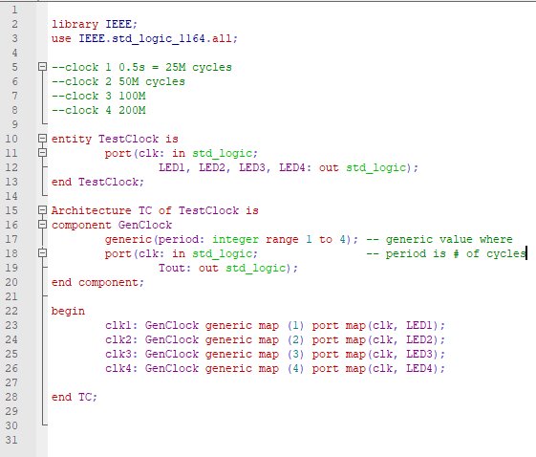

Figure . TestClock code.

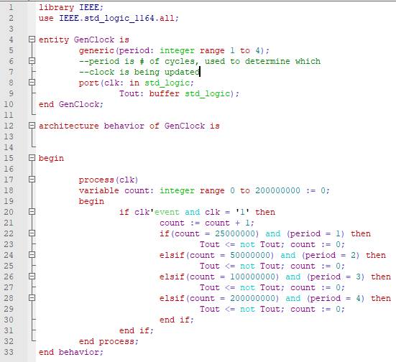

Figure . GenClock code.